Implementation guide

Implementation & Considerations:
For this project main area was deploying a honeypot on a cloud environment accessible to hackers. For this reason I had to choose between multiple cloud providers , AWS, And azure were the best options. From them I chose Azure because of the free 200 credits , which were enough for me to complete the project and analysis.
This part is where I will implement the VM’s fpor both management and Honeypot.
Anyone who is interested can go through this workflow in deploying this honeypot.

Advantages of Hosting on AZURE:
Had several benefits but the best ones were:
- Cost was low with 200 $ starting credits and if you are a student you qualify for 100 $ more.
- Easily adjustable machine specifications like RAM to match different workloads , Really good for scalability.
- Azures built in Firewall protects sensitive data.
- Azure had the lowest downtime best for applications such as honeypots.
- Simplified GUI streamlines and simplifies the whole deployment process.
To sum up, Azure was the best practical and efficient choice for this honeypot.

Resource group:
A dedicated resource group is needed to contain all project components( VM’s network, NSG , Ips)

Steps:
1- After creation of account just choose Create a resource or search resource groups.
2- You chose what subscription model you want , And you can name the resource group here
3- Selecting a region , You choose a region with your specific requirements, Remember some resources are only limited to some regions so. You choose region depending on your requirements , For Us Canada Central was the best option.
4- Press review and Create.
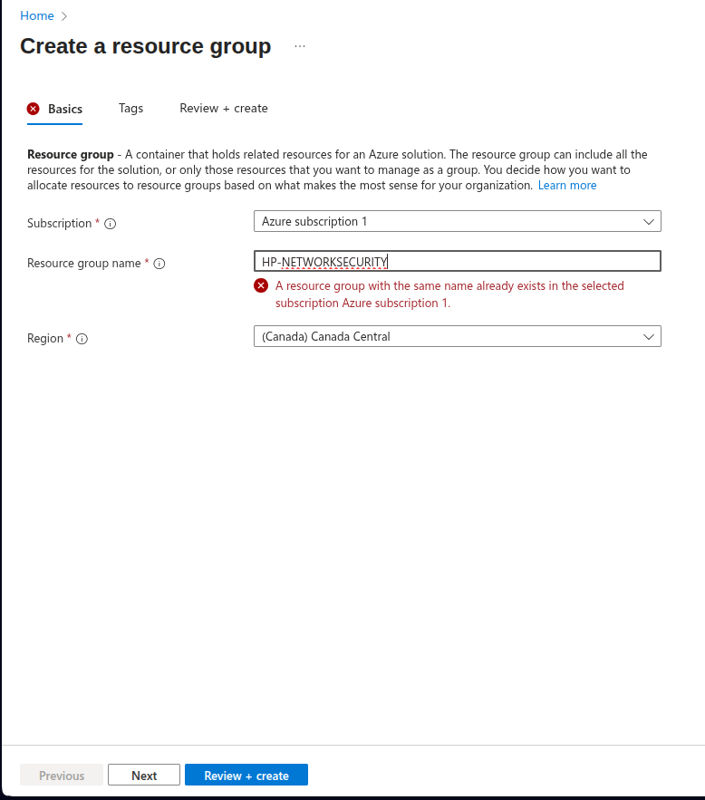

Virtual Network and Subnet:
Both VM’s (Management and Honeypot) will be inside this dedicated network. In best conditions would be 3 VM’s , 3rd being the actual financial decoy layer.

Steps:
1- Search Virtual networks in azure.
2- Click Create a New
3- Add in your resource group, And name it . With selecting the region best is to choose the same region as your resource group.

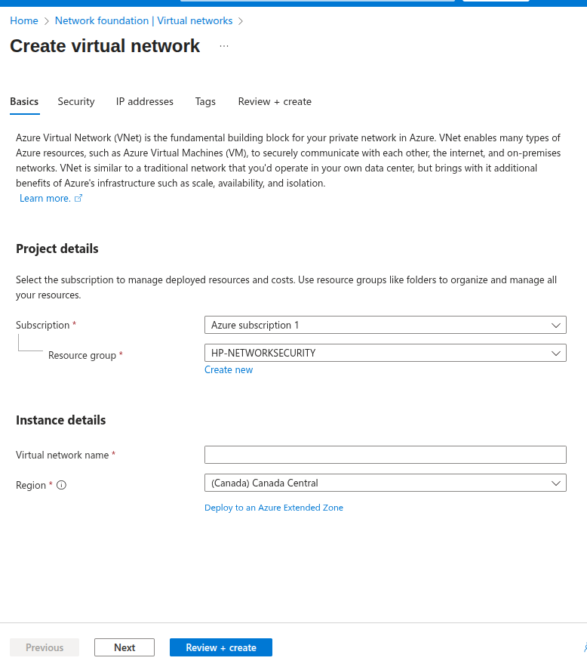

4- In IP address create your subnets. And review and create.

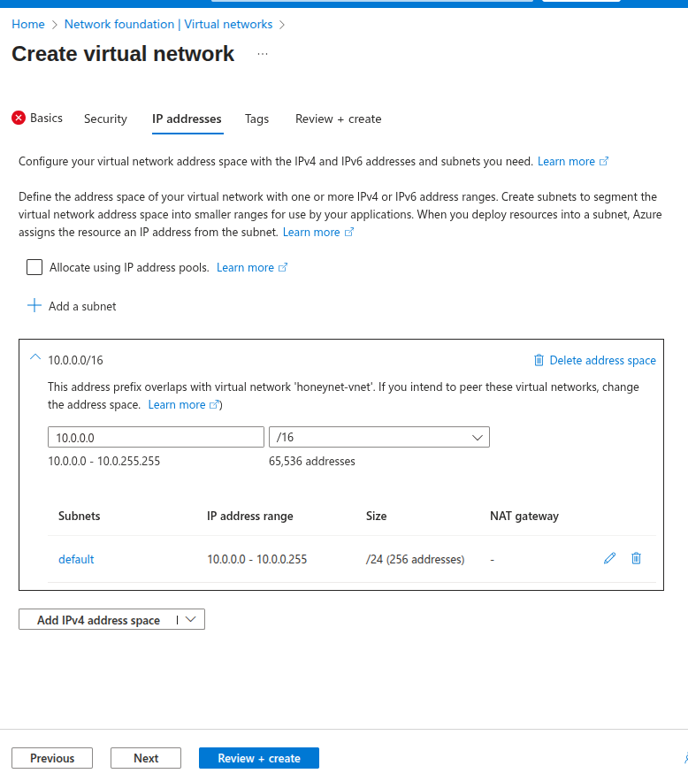

Network Security Groups:
This gives a controlled environment where all inbound traffic is either:
- Restricted to our own management IPs (for SSH/RDP)
- Intentionally open to the Internet for honeypot services.
You would need these equal to the number of VM’s You host, Each NSG being linked to its corresponding VM.

Steps:
1- Search Network Security Groups in azure.
2- Click Create a New
3- Add in your resource group, And name it . With selecting the region best is to choose the same region as your resource group.
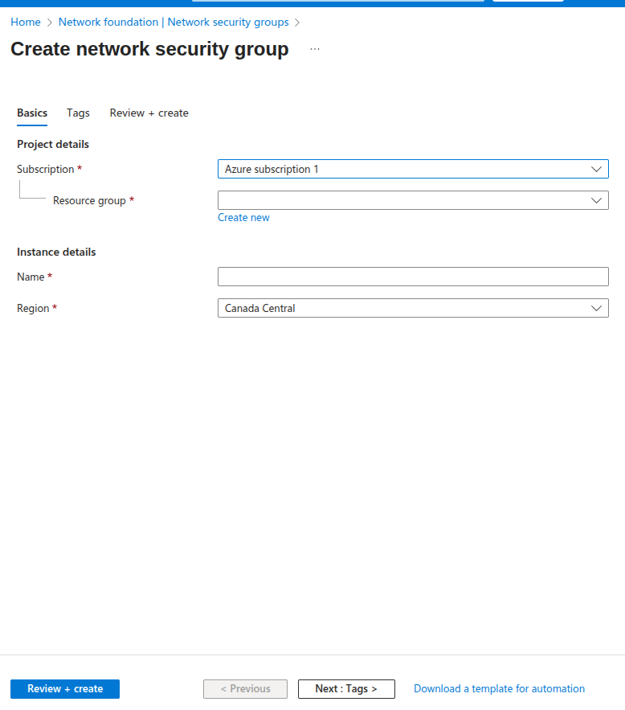

Deploying Management VM:
To avoid exposing administrative interfaces with Tpot and decoys, You make a dedicated Management VM. This acts as a jump box to access T-pot Honeypot via ssh and webUI. We run AZURE CLI on this for troubleshooting and managing , and keeping our laptop less exposed to direct internet facing resources.

Steps:
1- Search Virtual Machines in azure.
2- Click Create a New, Choose Virtual Machine from options.
3- Add in your resource group, And name it . With selecting the region best is to choose the same region as your resource group.
4-Choose an image, For me I used Ubuntu Server 24.04 X64 GEN2, with size for 2vcpus , and 8gb memory.
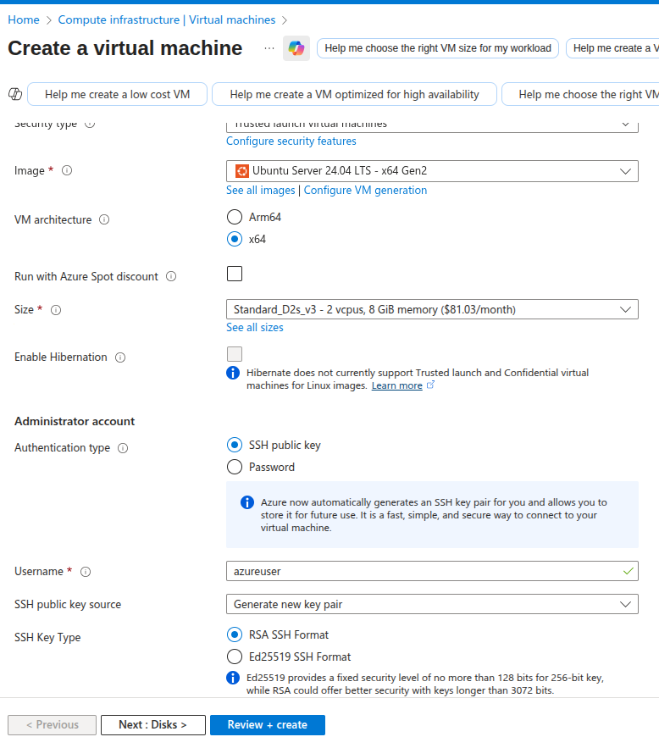
5- Choose SSH public key, and generate a new key pair, Or you could choose a password and user for simplicity.
6- Go to networking tab and connect to VNET you created.
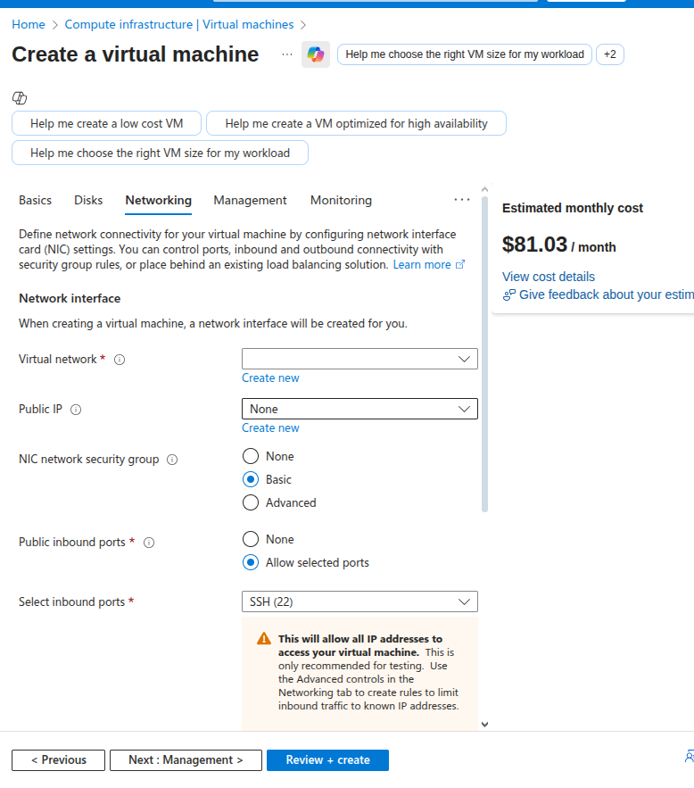
7- Leave everything else as could be set later and is not really needed, Review and create and create this VM.

Deploying Honeypot VM:
This is the VM for your honeypot deployment and all ports would be left open here , Use the same process as previous but use Password and username instead as the Honeypot would delete the SSH keys before you open it and will crash when you try logging in through ports.

--resource-group HP-NETWORKSECURITY \
--name tpot-vm \
--vnet-name hp-vnet \
--subnet hp-subnet \
--image UbuntuLTS \
--size Standard_D4s_v3 \
--admin-username mojiz \
--generate-ssh-keys \
--public-ip-sku Standard \
--nsg hp-nsg

Installing honeypot framework:
1- Install Git and clone T-Pot repository
sudo apt install git -y
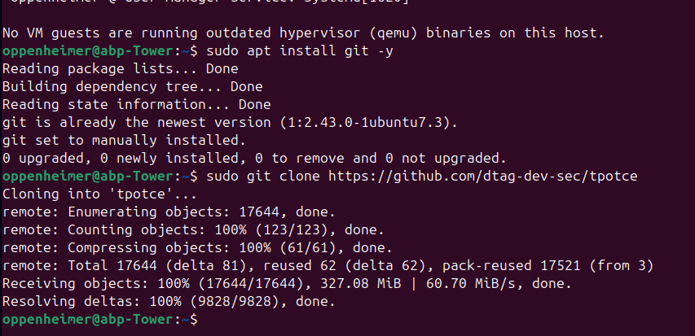
git clone https://github.com/telekom-security/tpotce.git

2- Running installer
cd tpotce
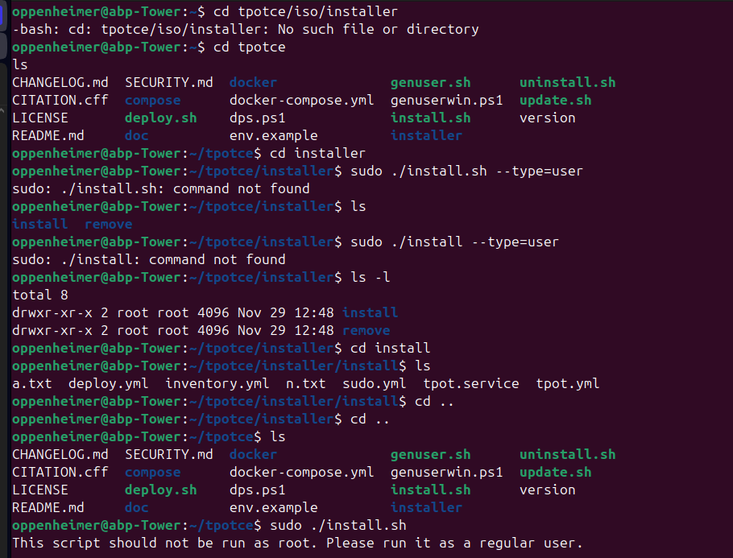
sudo ./install.sh –type=user
You will go in the installation directory tpotce and find an install.sh file, you have to run it through The normal user and not root.
3- Choosing -h as hive is the complete Tpot install medium
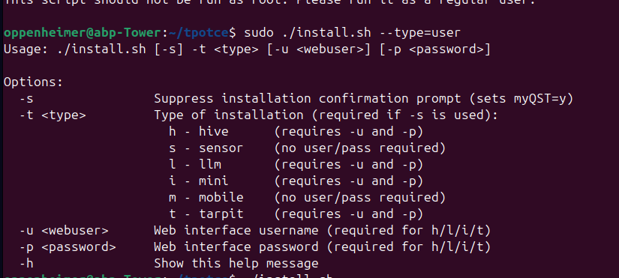
4-The installer will run and take some time
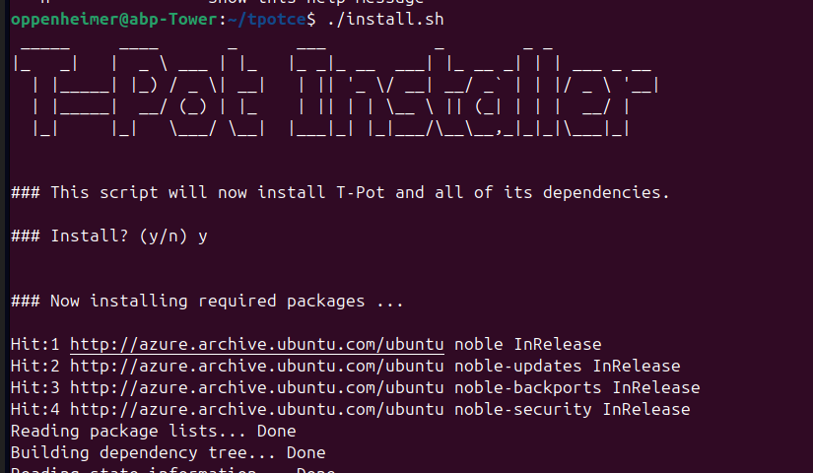
5- Once it ran it will show you network configs , and will tell to reboot
sudo systemctl status tpot
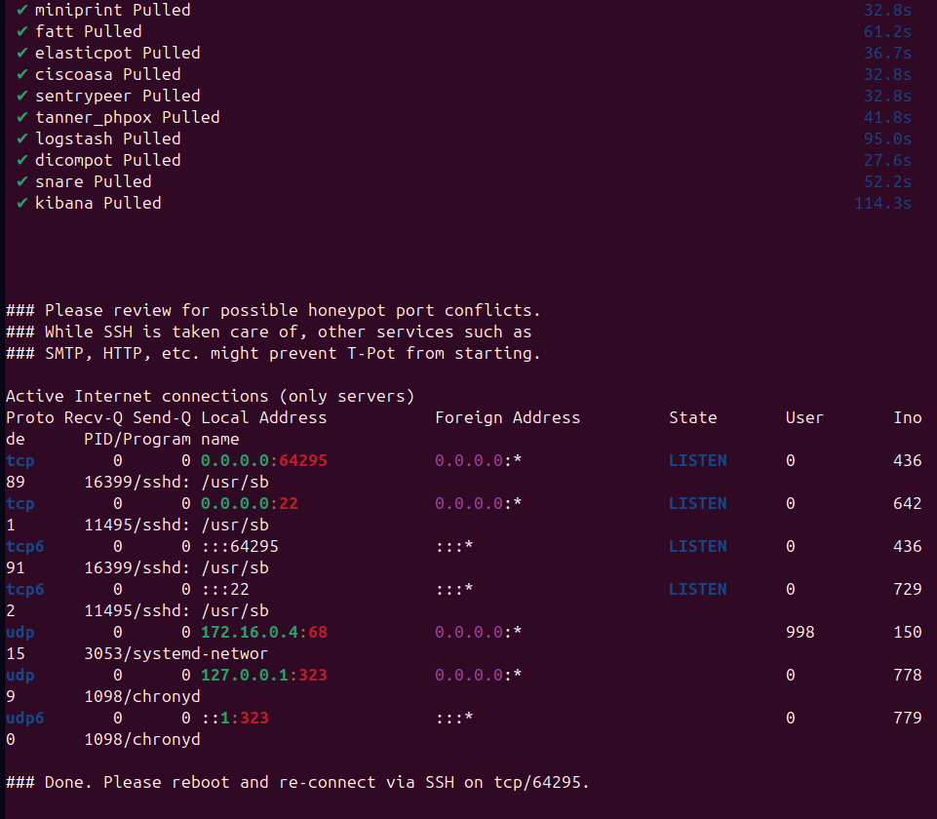

Deploying Financial Decoy:
To enhance the realism of the Honeypot, I deployed a financial decoy right next to it , which is a WEB/API decoy. This simulates an online banking login portal and money transfer API endpoint ,Allowing attackers to interact with a fake financial Application. All activity I slogged for analysis.
1- Create the decoy directory inside honeypot VM :
mkdir ~/financial-decoy
cd ~/financial-decoy

2- Deploying Financial WEB decoy:
index.html Frontend
financial_app.py Backend

This lightweight flask-based web app was made to attach the login page and provide a fake api endpoint which logs.
- API interactions
- Injection attempts
- Suspicious parameters
- Login attempts

3- Dependencies by using A virtual Environment:
This is made to avoid affecting T-pot services, And is a python environment
sudo apt install python3-venv -y
cd ~/financial-decoy
python3 -m venv venv
source venv/bin/activate
pip install flask

4- Running the financial decoy:
To keep it running over even when after terminal is closed systemd was created
sudo nano /etc/systemd/system/financial-decoy.service

The service configuration is used is :
[Unit]
Description=Financial Decoy Honeypot
After=network.target
[Service]
User=hpmojiz
WorkingDirectory=/home/hpmojiz/financial-decoy
ExecStart=/home/hpmojiz/financial-decoy/venv/bin/python3 /home/hpmojiz/financial-decoy/financial_app.py
Restart=always
[Install]
WantedBy=multi-user.target

Activating the service:
This was made possible by enabling the daemon
sudo systemctl daemon-reload
sudo systemctl enable financial-decoy
sudo systemctl start financial-decoy

Network Rules for Both Vms:
You can set these after going in your Specific VM and than Choosing networking in side options. Go to network settings.

Tpot- Honeypot / Financial decoy:
Inbound port rules:
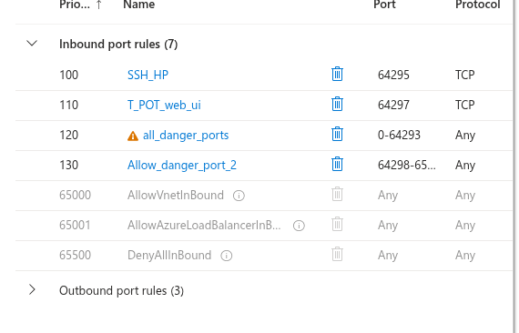
1- SSH-HP will help us out to ssh in it through our management vm.
2- T_POT_web_ui is the public facing port , Honeypot is deployed here.
3- We open all other ports as this is our decoy and we want attackers here.

Management VM:
Inbound port rules:
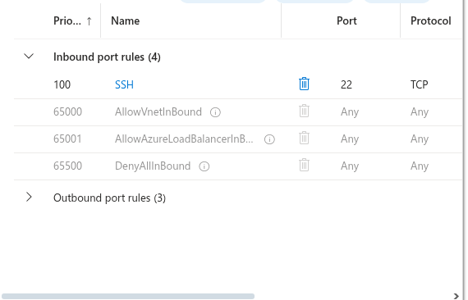
1- SSH , Only this as we SSH in management VM from our local pc To further SSH in our private VNET.

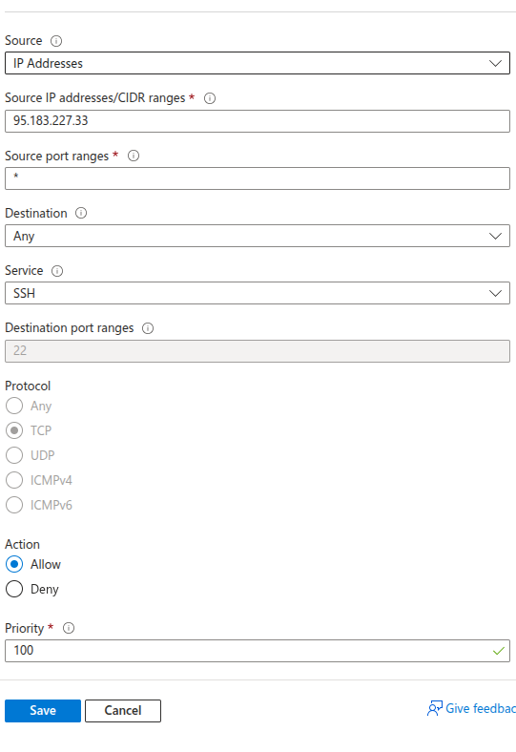
2- Over here we set the source as MY IP Address , which for security reasons and as our laptops jump from Internet to Internet , We would have to change everytime, In an organizational scenario we don’t have to worry about that.

Network Exposure Summary :

VM | Interface | Address | Exposed Ports | Source Allowed | Why
mgmt-vm | Public | 4.248.187.160 | 22 (SSH) | My IP only | Prevent public admin compromise
mgmt-vm | Private | 10.0.2.4 | N/A | VNET internal | Jump box routing
tpot-vm | Public | 130.107.48.120 | 64297 (T-Pot UI),  plus deception ports | Internet (decoy) | Attract attackers and collect telemetry
tpot-vm | Private | 10.0.1.4 | SSH from mgmt-vm (custom port mapping used) | VNET only | Prevent direct public admin
tpot-vm | Public (decoy app) | 130.107.48.120:8085 | 8085 HTTP | Internet | Financial decoy endpoint

Accessibility Overview:
This section provides a clear walk-through of how the cloud honeypot system was deployed and how it can be accessed. You follow each step As given for Access and usage.

Management VM Access overview:
Only the Managemement VM can be used to SSH into any host. Public mangement is intentionally restricted to prevent compromise of services.
So as we set my IP as the only IP which can access server you can see using Management VM’s public IP I used my username and Password to access my MGMT VM through my local computer.
Adresses:
1- Public IP address: 4.248.187.160
2- Priavte IP address: 10.0.2.4
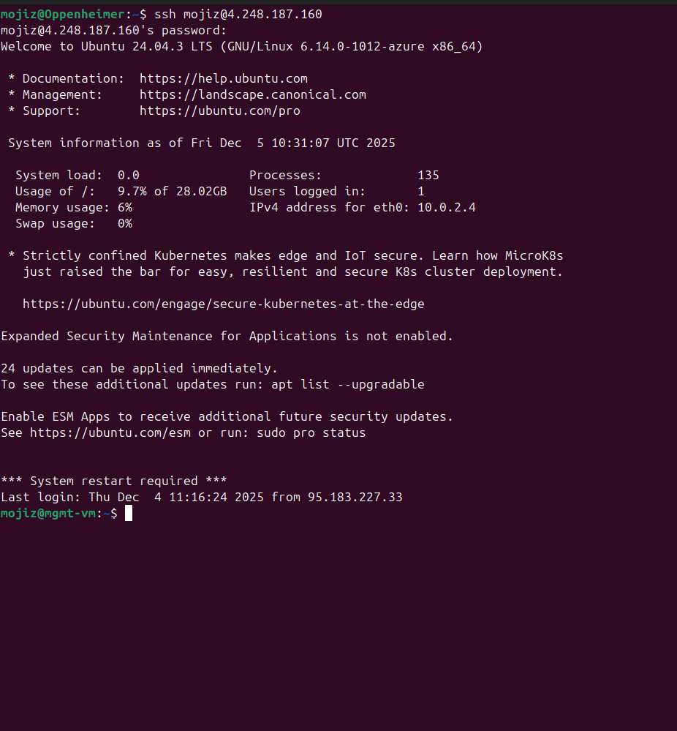

Honeypot VM Access overview:
So this VM cant be configured or directly SSH into through its public IP, Its public IP is specified for Honeypot usage only.
We can only manage this Using our private VNET and SSH has to be done in the Management VM for this.
Adresses:
1- Public IP address: 130.107.48.120
2- Priavte IP address: 10.0.1.4

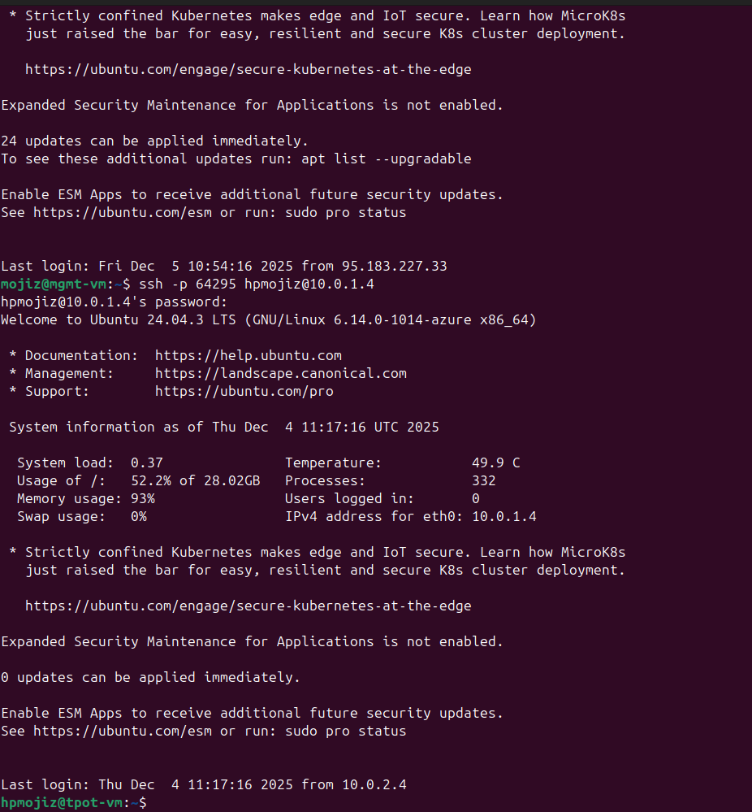

Honeypot Ports and services:
T-pot automatically runs the scripts and deploys multiple honeypots on the server each having a distinct port, These are important in collecting attacker traffic.
Service Type | Port | Honeypot Component | Purpose
SSH | 22 | Cowrie | Brute force + credential attacks
Telnet | 23 | Cowrie | IoT botnet recruitment traps
HTTP | 80 | Various web honeypots | Scanning, injections
HTTPS | 443 | Web decoys | Fake banking/API endpoints
SMB | 445 | SMB honeypot | Lateral movement traps
RDP-like | 3389 | RDP decoy | Windows-based attack simulation
Elastic/Kibana UI | 64297 | Web UI | Honeypot dashboard access

WE can access all these using the Public address of honeypot with the port specified as:
https://<tpot-public-ip>:64297
For this case:
https://130.107.48.120:64297
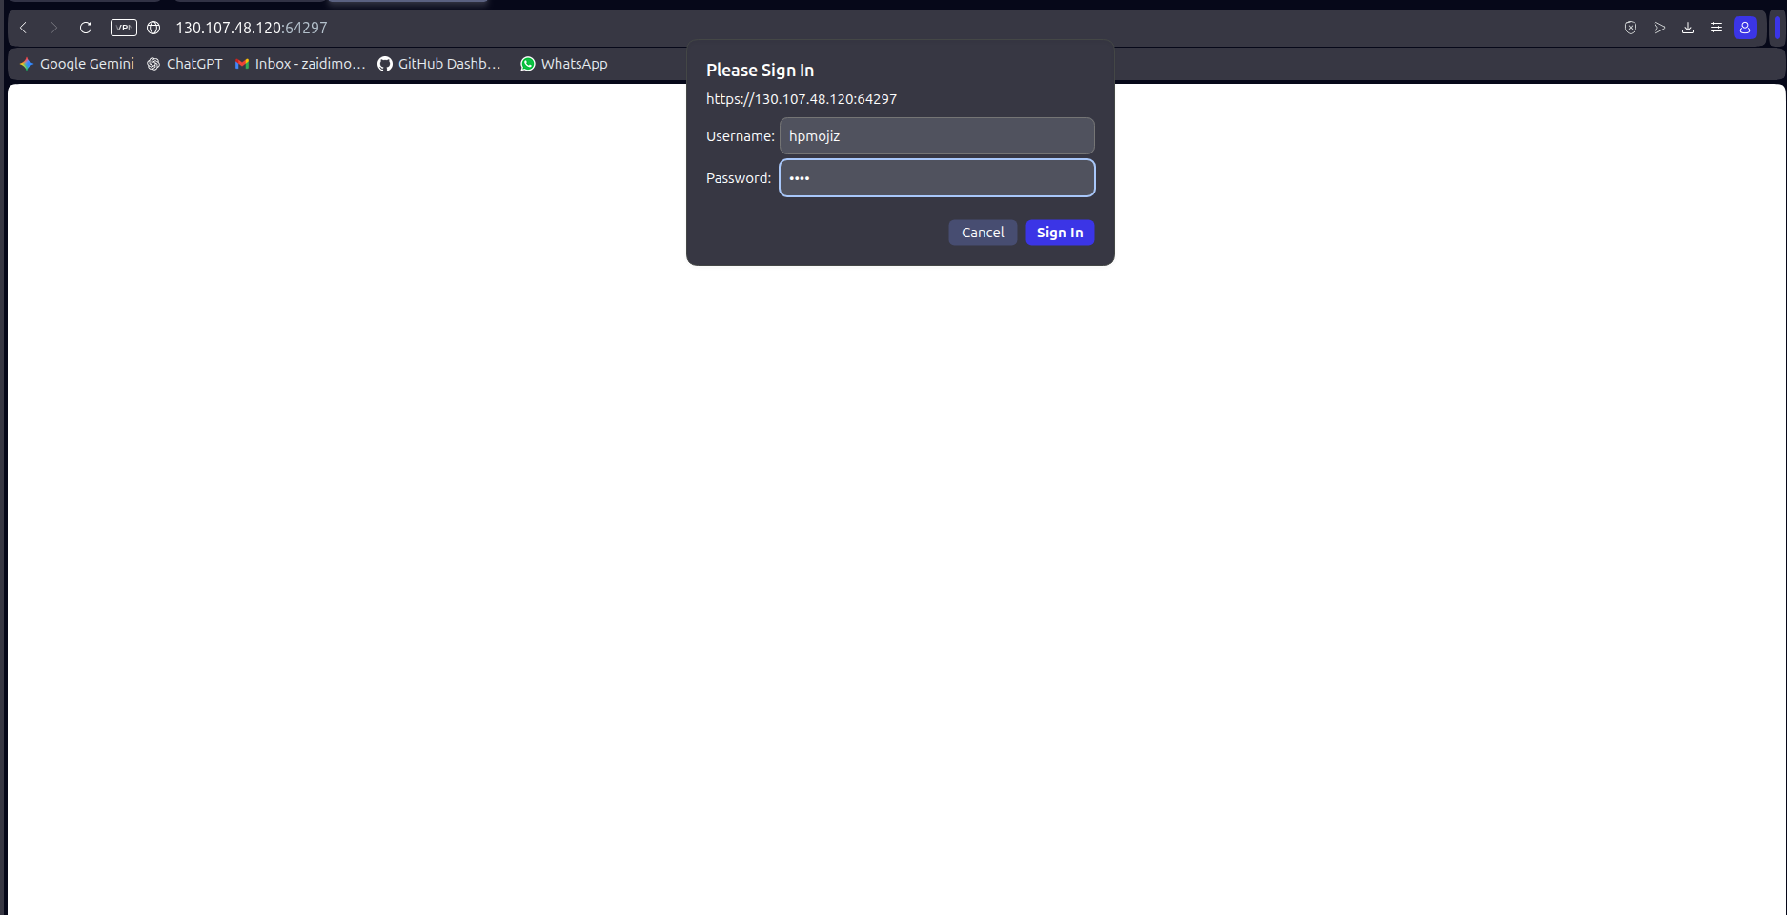

Here it asks for a username and password you created during T-Pot installation and than takes you to the T-Pot GUI.
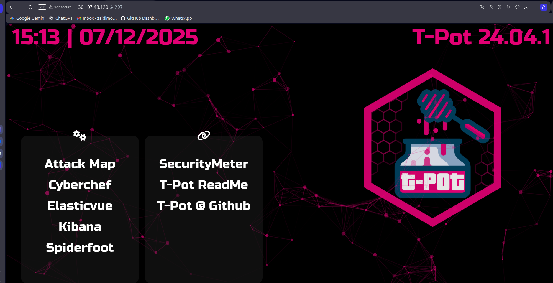
The T-pot GUI is Further divided into multiple Web interfaces, Kibana being the dashboard and Attack Map being the map of where and how attacks happened.

Financial Decoy:
The financial decoy is now activated at port 8085 with a TCP
As the honeypot was allowed to take all inbound connections didn’t have to change any network configurations for this.
Using the honeypot VM’s public IP we can access it
http://130.107.48.120:8085
Keep the HTTP header as attackers exploit This instead of HTTPS.
When attackers interact with this they will trigger:
- / Fake banking Login
- /login Fake dashboard showing details (Making them think they logged in)
- /api/transfer?amount=X^to=Y Fake transfer API endpoint
All these interactions are logged in Honeypot VM.

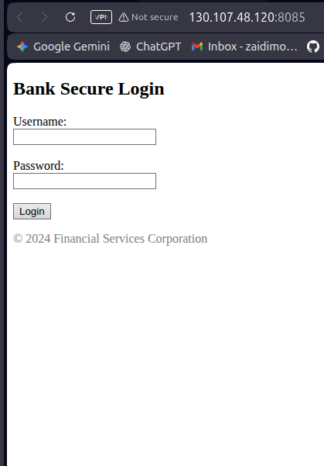
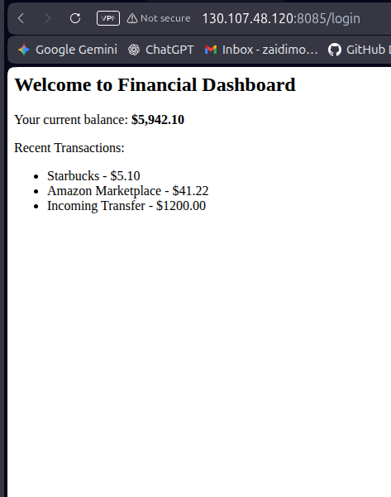

Operational maintenance and realism strategy:
To keep decoys realistic overtime the environment should mimic plausible patterns :
- Realistic service banners and endpoints.
- Fake but consistent dummy data to avoid “Empty system” Indicators.
- Normal background traffic generation to avoid “Silent host” fingerprinting.

Minimizing Human effort:
Human effort is reduced by :
- Centralizing telemetry in kibana for quick triage.
- High confidence signals , like any interaction with decoy is labeled suspicious.
- Automating enrichment (Extracting attacker IP and endpoint)
- Defining thresholds for response.

Log ingestion Of financial decoy to Kibana:
The financial decoy writes HTTP access logs to
/var/log/financial-decoy.log .
We configure Firebeat to monitor this file and forward events to local elastic search instance used by T-POT. Events were indexed under the pattern financial-decoy-YYYY. MM. DD. A kibana data view Financial-Decoy-* was created with @timestamp as time filed to enable analysis in Discover.
You can follow these steps to configure the files for Kibana.
- Confirm financial decoy is logging locally:
In tpot VM the access logs are written to /var/log/financial-decoy.log verify using
sudo tail -f /var/log/financial-decoy.log
After visiting http://<tpot-public-ip>:8085 and submitting a fake login you can see logs appear as
  - GET/
  - Post /Login
  - Client Source IP in beginning of each line.
- Identify elastic search port used by T-POT:
Find port using docker ps | grep elastic
Example: 0.0.0.0:64298 → 9200/tcp
so , The port is 64298 for ElasticSearch
Endpoint will be visited as
http://localhost:64298
- Configure Filebeat to send decoy logs to ElasticSearch:
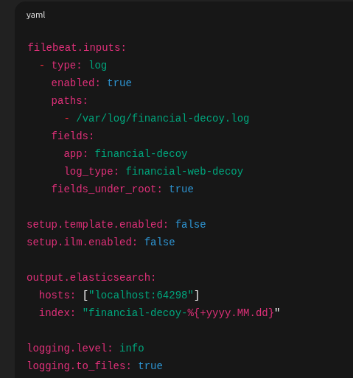
Filebeat was configured to read logs from /var/log/financial-decoy.log continuously and send events to Elasticsearch.
Open the config file : sudo nano /etc/filebeat/filebeat.yml
Input configuration in image
key points:
- paths point to decoy log file
- Index forces a dedicated pattern
- fields under root adds app and log type
All these are done for easy filtering each interfaces logs

- Validate & restart Filebeat:
Check synatx files: sudo filebeat test config
Restart: sudo systemctl restart filebeat
sudo systemctl status filebeat
Filebeat should show : active running
- Check if data arrived in ElasticSearch:
List indices to check Financial decoy exists:
curl -s "http://localhost:64298/_cat/indices?v" | grep financial
Verify sample documents:
curl "http://localhost:64298/financial-decoy-*/_search?size=5&pretty"
Now the decoy logs are being stored in ElasticSearch.
- Creating Kibana Dataview:
Open kibana: https://<tpot-public-ip>:64297
then :
  - Stack Management → Data Views
  - Create the Data View
  - Index pattern: financial-decoy-*
  - Timestamp Filed: @timestamp
  - Save
Now kibana discover can query all decoy logs
- Create runtime field: attacker_ip:
  - Stack Managemnt → Data Views → Financial_decoy → Addfield*
  - Use : Name: attacker_ip, Type: IP
  - add this in runtime script:
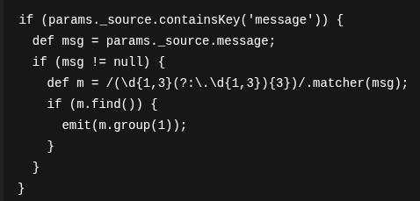

This extracts the first IPV4 address from the log line.
- Create runtime field: http_method:
  - Use : Name: http_method, Type: keyword
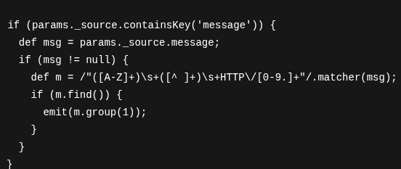
- Create runtime field: url_path:
  - Use : Name: url_path, Type: keyword
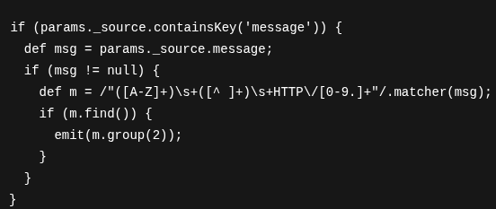
- Use runtime fields in Discover:
  - Discover → select data view financial-decoy-*
  - Columns add:
attacker-ip , http_method , url_path
Now each event shows
which attacker ip accessed decoy, which endpoint was used. Which method was accessed
This structure will help in automating NSG rules , and check threshold based ip extraction as well as generating candidate data for deny rules to be put in azure.

Setting | Value | Why
input path | /var/log/financial-decoy.log | reads decoy access logs
output | localhost:64298 | ships to T-Pot Elasticsearch
index | financial-decoy-%{+yyyy.MM.dd} | daily index management and separation
fields | app=financial-decoy, log_type=financial-web-decoy | filtering and correlation

